1. First Iteration Use Case Description

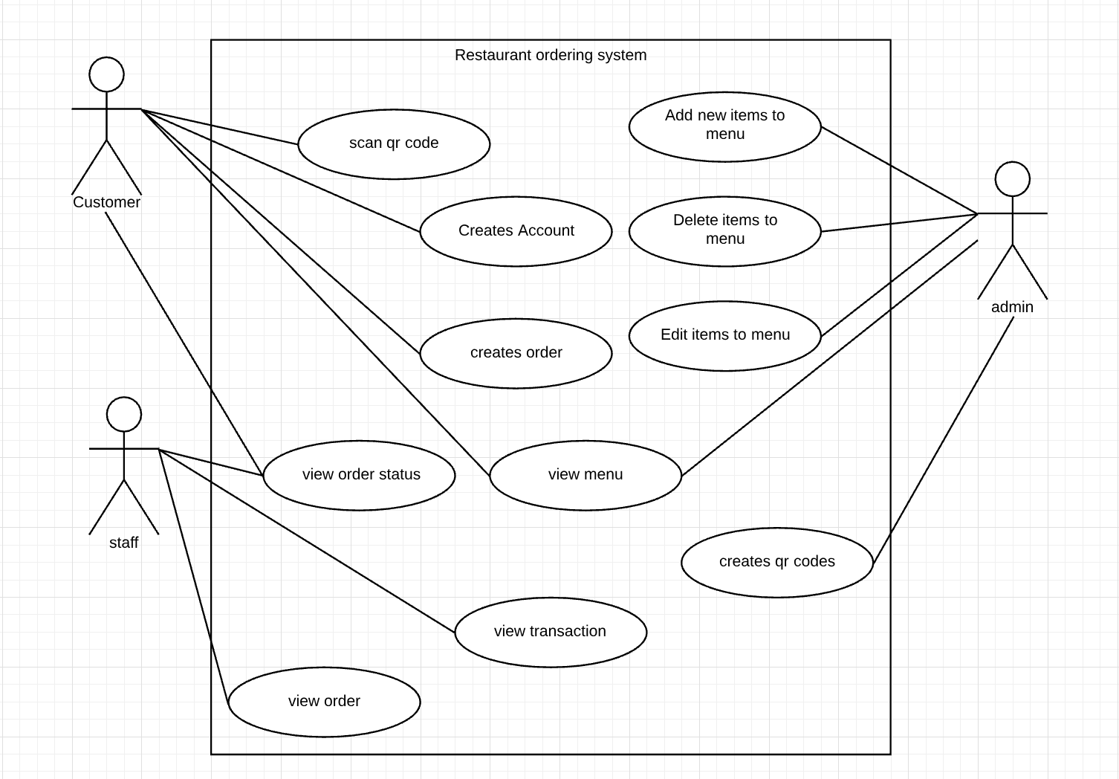

|  |  |  |
| --- | --- | --- |
| **USE CASE** | | Restaurant order system customer and staff |
| **Description of Goal in Context** | | The system will ask for user’s information before scanning qr codes in restaurants. Information like email, name, allergies. After user creates an account and scans a qr code the menu of the restaurant will appear. |
| **Preconditions** | | We know nothing about the user.  We know which restaurant menu to show to users |
| **Post Conditions, Success End Condition** | | We have information about the user, user will be given recommendations. |
| **Main Flow** | | |
| **Step** | **Action** | |
| 1.1 | User creates account | |
| 1.2 | User enters allergies | |
| 1.3 | User scan QR code to view menu | |
| 1.4 | Generate a few recommended dishes based on user’s details | |
| 1.5 | User can add food/ drink items to cart | |
| 1.6 | User can check out and pay by card through app | |
| 1.7 | Check payment received. Waiter checks transaction status | |
| 1.8 | Order sent to kitchen | |
| 1.9 | User and waiter can check order status | |
| 2.0 | End use case | |

|  |  |
| --- | --- |
|  | |
| **EXCEPTIONS ERRORS** | |
| **Step** | **Branching Action** |
| 1.6.1 | While using the app only card payments are available. |
|  |  |
|  | |
| **ALTERNATIVE VARIATIONS** | |
| **Step** | **Branching Action** |
| 1.1 | Unique email and password to validate user |

1. Second iteration

|  |  |  |
| --- | --- | --- |
| **USE CASE** | | Restaurant order system admin POS |
| **Description of Goal in Context** | | The system will ask the admin to log into their account. The admin should be the manager of the restaurant. The admin can create, read, update and delete menu items |
| **Preconditions** | | We know that the manager can access this information. |
| **Post Conditions, Success End Condition** | | We have information about the admin and all the staff.  We have information of menu items |
| **Main Flow** | | |
| **Step** | **Action** | |
| 2.1 | Admin logs on to POS | |
| 2.2 | Admin can perform the CRUD functions to menu items | |
| 2.3 | Admin can see all staff members | |
| 2.4 | Admin can analyse POS | |
| 2.5 | End use case | |

|  |  |
| --- | --- |
|  | |
| **ALTERNATIVE VARIATIONS** | |
| **Step** | **Branching Action** |
| 2.1 | Unique ID and password to validate Admin |